**Maximum Profit in Job Scheduling:**

We have n jobs, where every job is scheduled to be done from startTime[i] to endTime[i], obtaining a profit of profit[i].

You're given the startTime , endTime and profit arrays, you need to output the maximum profit you can take such that there are no 2 jobs in the subset with overlapping time range.

If you choose a job that ends at time X you will be able to start another job that starts at time X.

**Example 1:**

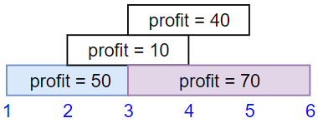

**Input:** startTime = [1,2,3,3], endTime = [3,4,5,6], profit = [50,10,40,70]

**Output:** 120

**Explanation:** The subset chosen is the first and fourth job.

Time range [1-3]+[3-6] , we get profit of 120 = 50 + 70.

**Example 2:**

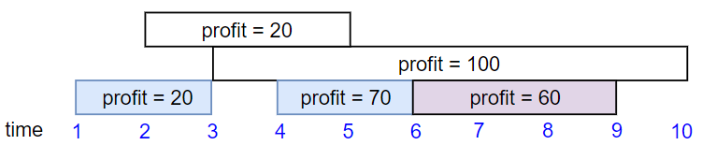

**Input:** startTime = [1,2,3,4,6], endTime = [3,5,10,6,9], profit = [20,20,100,70,60]

**Output:** 150

**Explanation:** The subset chosen is the first, fourth and fifth job.

Profit obtained 150 = 20 + 70 + 60.

**Example 3:**

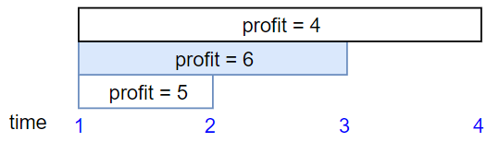

**Input:** startTime = [1,1,1], endTime = [2,3,4], profit = [5,6,4]

**Output:** 6

**Constraints:**

* 1 <= startTime.length == endTime.length == profit.length <= 5 * 10^4
* 1 <= startTime[i] < endTime[i] <= 10^9
* 1 <= profit[i] <= 10^4